Greek Theatre Quick Facts

The Theatron
Thymela – originally an altar on the orchestra, this became the spot where the leader of the chorus (koryphaios) would stand.
Koilon (or Theatron) – the auditorium of the Greek theatre. Originally, the audience just sat on the slope of the hill, looking down to the orchestra. Over time, the Koilon was built, first of wood, then stone.
Diazoma – upper and lower levels of the Koilon (auditorium).
Scene (pronounced SKAY-nuh) – was a temporary enclosure with doors. Performers would get into masks and robes in the scene and enter through the doors, which represented the temple or palace
Proscenion – the area directly in front of the scene where the actors would perform. NOTE: the proscenion gradually became the acting area – the original acting area was the orchestra.
Parados – were aisles that actors would use to enter if they were supposed to be coming from outside (not the temple or palace). The right parados came from the city or port; the left parados led from the fields or abroad
Klimakes- Audience stairways in Greek seating area (theatron). The staircases (klimakes) that separated the wedge-shaped seating sections (kerkides) of the Greek theatron. In multi-tiered theatrons, the staircases lead to curved walkways (diazomata) that separated the seating galleries.
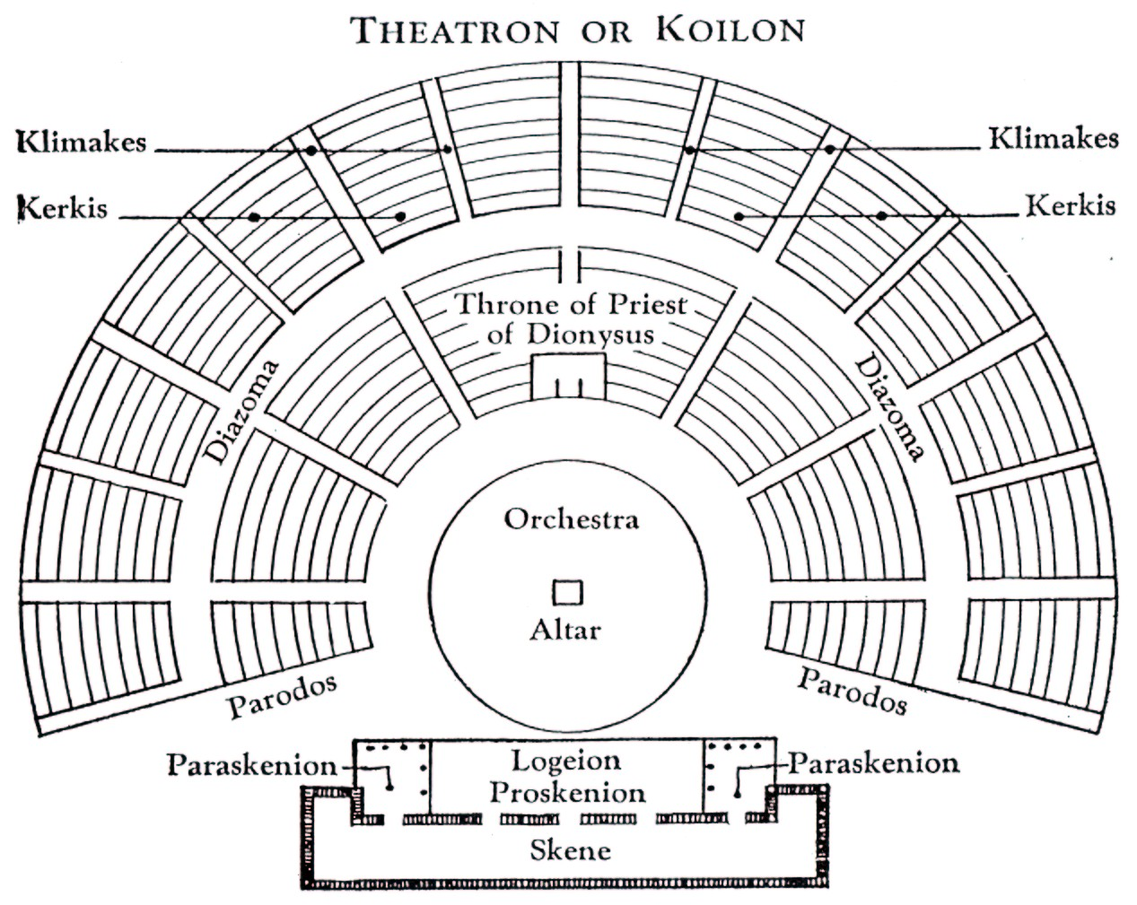

Quick Facts:
- Ancient Greek drama, is a theatrical culture that flourished in ancient Greece from c. 700 BC.
- Athens Drama Festival originated from the Great Dionysia, a festival where people would take part in performances that explored great issues in their society.
- The earliest tragedy that survives, is Aeschylus Persai, dates from 472
- The festivals were attended by all Athenian citizens (women as well as men) and visitors from throughout Greece.
- Performances took place in amphitheatres and these were very big.
- Performances were performed in the open air.
- Semi-circular shape with rows of tiered stone seating around it. The shape of the theatres gave everyone in the audience excellent viewing and also meant they could hear the actors well too.
- The stage was raised within the circle – this shape made sure all the audience could see and helped amplify the sound.
- Very important visitors would sit in the front seats.
- Greek plays were either comedies or tragedies. Tragedies were often about the past, whereas comedies tended to be about current and everyday life.
- The Drama Masks which are so often associated with the subject originate from Greek Theatre and stand for Comedy and Tragedy.
- Some famous playwrights include: Aeschylus, Sophocles and Euripides (who wrote tragedies) and Aristophanes (who wrote comedies).
- All the actors were men.
- Instead of one actor telling a story a group of actors known as a chorus worked together.
- Chorus worked in movement and voice so that stories could be heard and movements seen.
- A chorus consisted between 5 and 50 actors.
- The audience would throw food and stones if they thought the acting wasn’t good enough!
- They wore large masks that exaggerated facial features and emotions.
- The actors wore masks, bright colours for comedies and dark colours for tragedies.
- The masks were made from fabric and stiffened with plaster.
- Thespis is the first actor and where we get the term thespian.
- You need to know the story of “Oedipus”.

