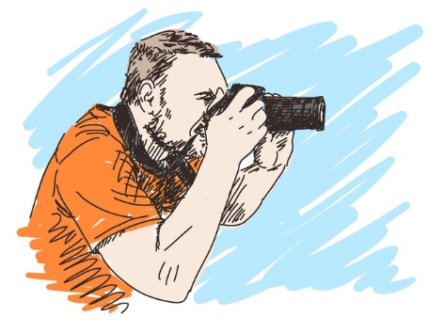
Head Shot Assignment

This will be entered at a quiz grade. Head shots will be displayed on the drama bulletin board.
The goal of this activity is for students to have a semi-professional head shot that could be used for college auditions or other theatrical auditions. This will also be used in the audition process for the short film class.
TAHSFTII.9 Exploring the business of theatre
What’s in a headshot? For starters: your look, your brand, your type, your age range, your possible occupations, your professionalism, your socioeconomic background, your personality traits, your inner emotional life…Yikes! That’s a lot of pressure to put on one photo! Is your headshot really that important?
The simple, honest answer is “Yes!” Your headshot is a crucial part of your package; in fact, it’s the front page. You may not judge a book by its cover, but you will certainly be judged by your headshot. Your audition begins the moment you walk into the room, but your headshot may allow or prevent you from getting into that room in the first place.

Assignment: In teams take headshots for one another. You may use a DSLR or an iPhone 7 or 8 plus (it needs to have the double lens). I will allow students to borrow my phone and camera during this process.
The finished photo will be added to the google drive. You may edit photos if you find it necessary.
Things to Consider:
1. Go for personality over glamour.
Make sure it looks like you. Chill with the airbrushing. Casting directors expect you to look just like your headshot, and will not be happy when you show up looking totally different, or 10 years older. It’s not about looking pretty, it’s about representing your type, age wrinkles included. It should look like you on your best day, showing your age, and who you are now.It’s not about the type you want to be, it’s the type you are.
2. It’s all about the eyes.
Just like with on-camera acting, it’s all about the eyes, and what’s happening behind them. It’s your closeup, your moment. Your eyes should be perfectly in focus, alive, and energized, and not dead and glazed over. There should be strong inner thoughts, implying a backstory and a life behind the eyes. A slight squint, and strong piercing eyes will bring a picture to life and help it stand out in a pile of hundreds. A good headshot photographer knows how to bring this out in you.
3. Pay attention to framing, lighting, and background.
In general, a good headshot is chest up with good lighting on your face, and no strong dramatic shadows, unless you are going in for “The Phantom of the Opera.” Three-quarter shots are good for print, and extreme closeups are good for, well, nothing. Look directly into camera, and the focus should be on the center of your eyes, not your left ear, or your shirt collar. No peace signs, weird facial hair, or the famous “hand on face” pose. Be sure the background is blurred, which means it’s shot with a good, high quality camera with a high-depth of field, which makes you stand out. We don’t need to see that you are standing on the beach in Santa Monica, or on a tour boat in front of the Statue of Liberty. It’s about you, not the environment.
4. Natural light vs. studio.
Some photographers do both, as they offer a different look and feel. Natural light gives a very real, “film” look, which I prefer. Studio lighting tends to be a little more polished, with a more neutral backdrop. Both can be wonderful. If you are more of a sitcom actor, perhaps a good well-lit studio headshot is more suited for you. If you want to look like you are on “True Detective,” then go for the outdoor look.
5. Clothing and props.
I once saw a headshot of a guy with a bird on his head. Why? Because he wanted to stand out. Let’s not get crazy here. Keep it simple and classy, and follow the standard format. Professionalism gets you noticed, not desperation. Leave the Ed Hardy and the “statement” shirts at home. A simple, solid color shirt with a little texture that fits you well and matches your eyes should do the trick. No whites, and no graphics or anything you think might distract from your face. And no props. (You know that, right?) If you think you are going to play cop roles, you don’t need to wear the outfit in the headshot. It’s a bit much, and very limiting.
6. Don’t go crazy with the makeup.
Yes, lots can be done with retouching. There is no need to put on tons of makeup. You want to look like yourself on your best day, and not look like you tried too hard. Girls, be yourself, do your hair the way you would for every audition. Guys, bring some oil sheets to take down the shine, and maybe use a lightly tinted moisturizer to take out the redness and even your skin tone. Some people spend way too much on makeup, only to have to get their headshots redone afterwards because they look fake in all the photos.

