Homemade Special Effects Makeup
By Jennifer Sandberg ; Updated September 15, 2017

Things Needed
- To make face paint:
- 2 tbsp. cold cream
- 5 drops liquid dish soap (ex. Dawn)
- Food color (black, blue, red and white suggested)
- 1/4 cup corn starch
- Empty egg carton

- To make fake blood:
- 1/2 bottle of light corn syrup
- Very hot water
- 1 tsp. liquid dish soap (ex. Dawn)
- Red, blue and green food coloring

- All other supplies:
- Plaster
- Small paint brushes
- Small spatula
- Small black shirt buttons
- Black thread
- Rich face moisturizer
- Face powder or talc
- Dark grey eye shadow
- Sticky tape
- Liquid eyeliner pen
- Vaseline or other petroleum jelly (or use Derma Wax, which is costume wax but some use it for skin healing properties)
- Empty Mountain Dew plastic soda bottle
- Face makeup foundation (ex. Cover Girl)
- Scissors
- Gum
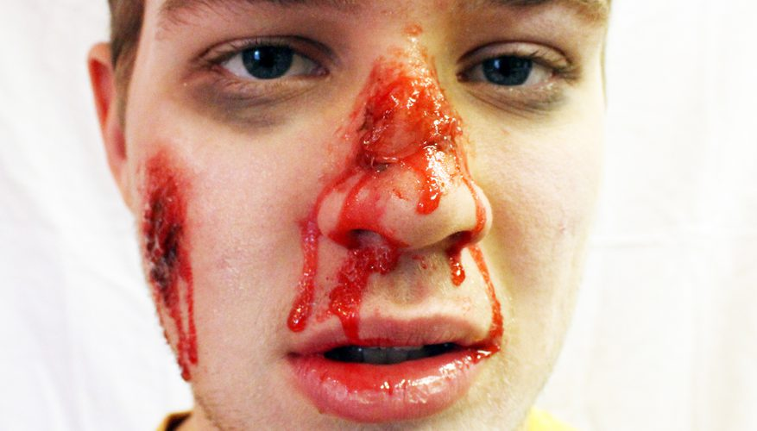
Special effects makeup isn't just for the movies. Items from your kitchen, bathroom and garage serve as essentials of a perfectly haunting look. The basics of special effects makeup is to take a naked face and create an illusion of something traumatic, disgusting and perfectly scary. With a little technique and a lot of imagination, create features like a broken or bloody nose, open wound, bruises and even bullet holes. Choose to feature one effect or a combination of many.

Prepare Face Paint and Fake Blood
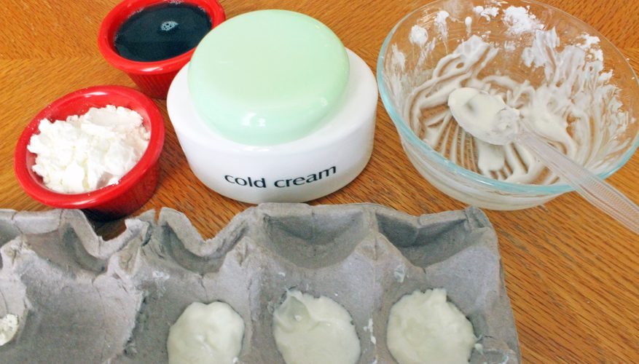
Mix face paint by combining cold cream, dish soap and corn starch well, and pour evenly into an empty egg carton.
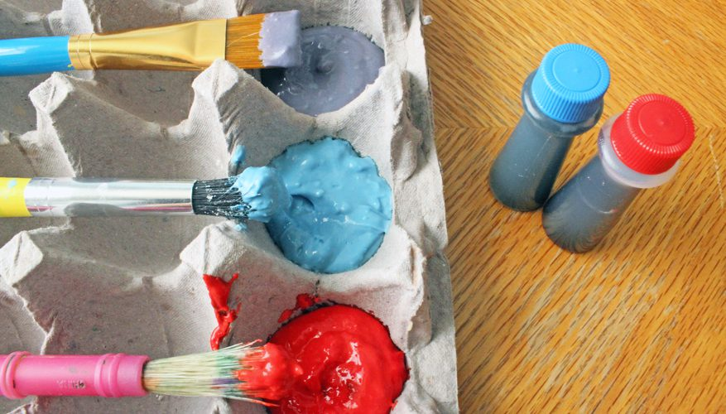
Add two to three drops of food coloring (repeat these steps as needed).
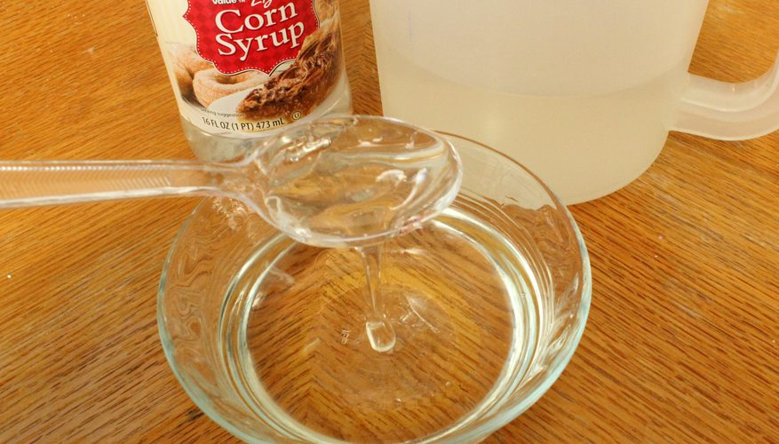
Mix fake blood by combining the corn syrup and water in a small bowl, adding water gradually to achieve a substance that is sticky and relatively thick.
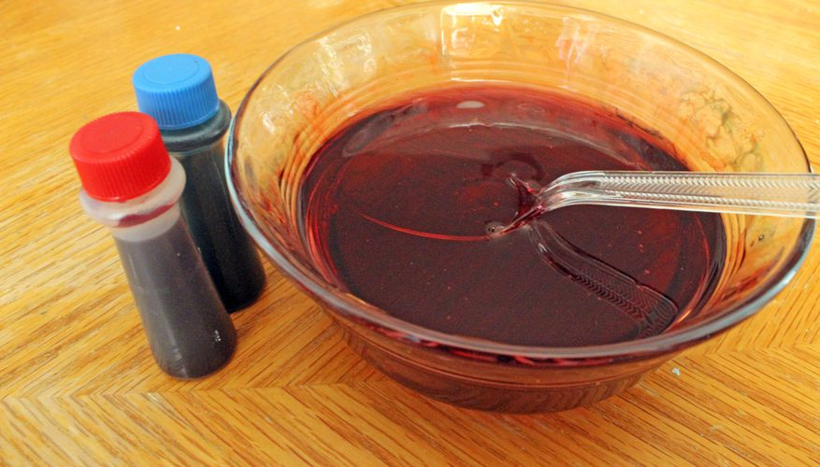
Add red food coloring and stir until you think the mixture looks like blood. Darken the blood by adding the blue and green food coloring.

Facial Bruises and Bloody Wounds
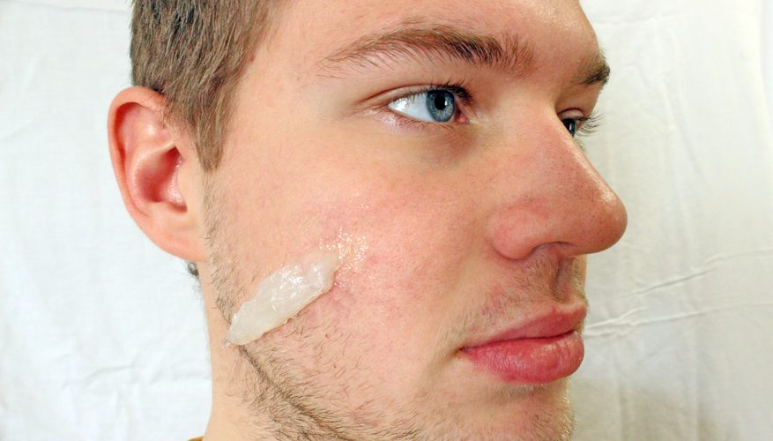
Create a facial gash. Roll some Vaseline (or Derma Wax) into a cylinder and press it into your skin. Vaseline or Derma Wax is used to mold the special effect because it is easily painted and blended to look like a part of your skin.
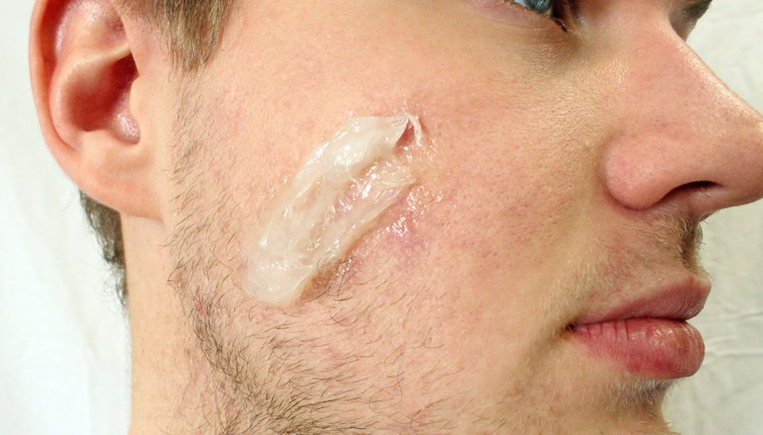
Run a small spatula over the center of the Vaseline to create as jagged a wound as you’d like.
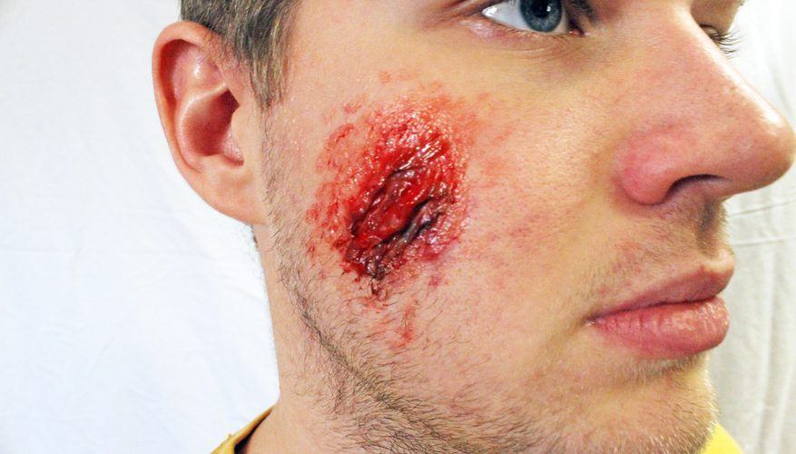
Color the bottom of the wound with black face paint and use dark red face paint to color the inside and outside edges of the gash. Blend the color into your actual skin to create a seamless look.
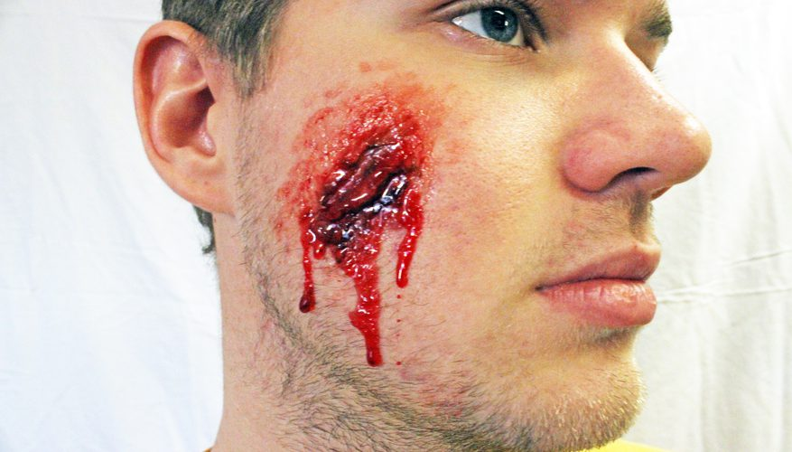
Add fake blood dripping from the wound with a small paintbrush to make it appear the gash is bleeding.
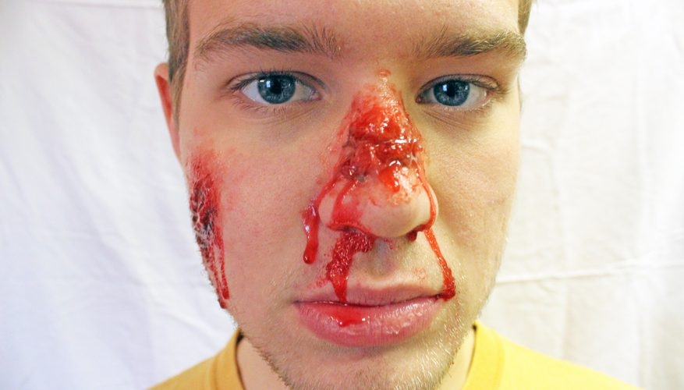
Create a broken and bleeding nose. Press a ball of Vaseline or wax into the bridge of your nose where you want it broken. Follow steps to create a gash wound above.
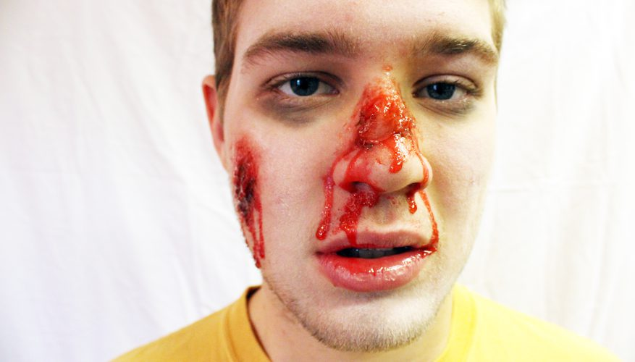
Apply face powder or talc with a cotton ball or makeup pad to make the skin appear pale and bruised.
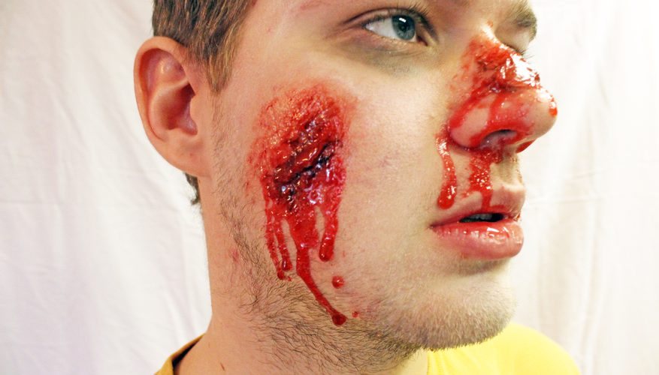
Add dripping blood by pouring fake blood into the gash and letting it roll down your face.

Bullet Holes
Spot the placement of the bullet hole on your forehead with a dime-size dab of black makeup.
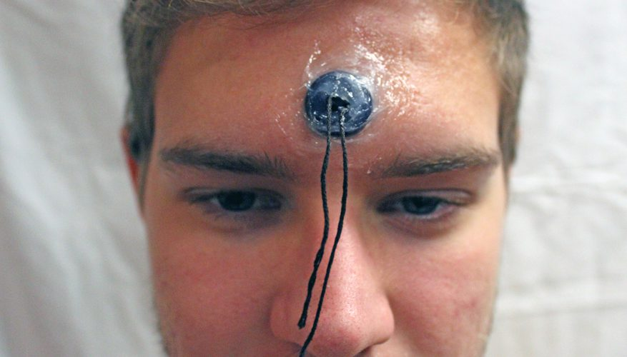
Tie a piece of thread to a small black button, lay it over the black dot and cover the button with Vaseline or wax leaving the string hanging out of the mold.
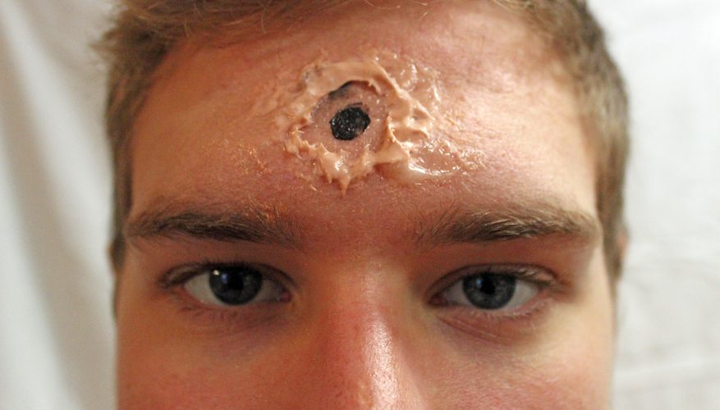
Blend in some flesh- or black-colored makeup over Vaseline or wax, then quickly tug the string to create an open cavity.
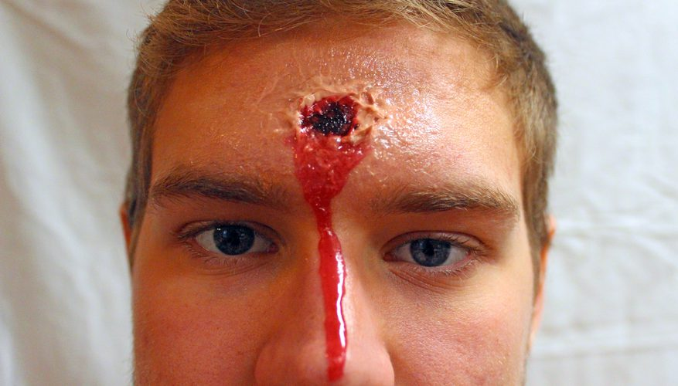
Fill the resulting cavity with fake blood. If you want the bullet hole to look less fresh use plenty of face powder or talc making the wound look dry.

Glass Shards in Face
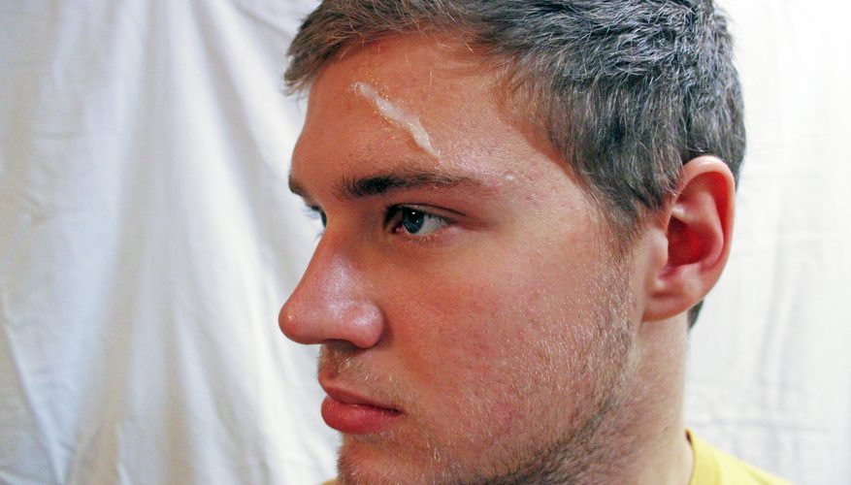
Roll some Vaseline or Derma Wax into a ball and press it into your face where you want the "glass."
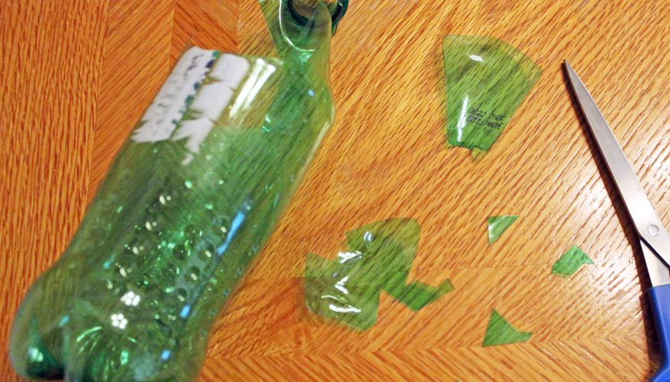
Cut the Mountain Dew bottle into shapes to represent broken glass.
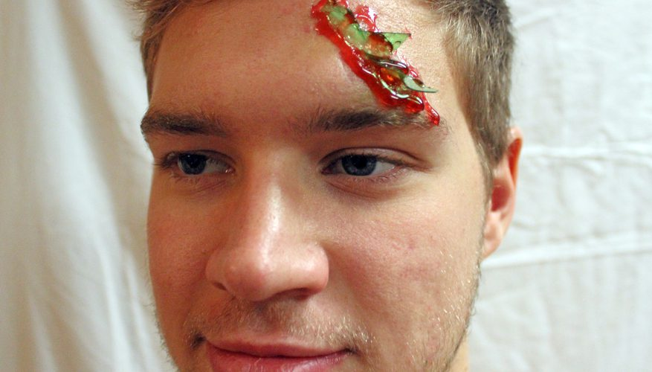
Embed the shards of the Mountain Dew bottle into Vaseline or Derma Wax with light pressure until they stick. Gum can also be used to affix the shards. Add fake blood for effect.

Missing Finger
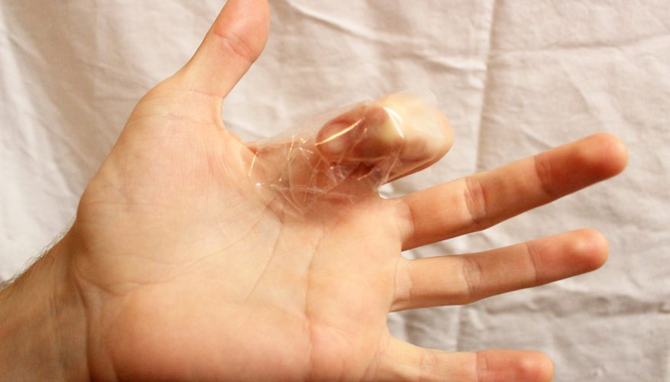
Bend the finger you want to look chopped off at the knuckle, and tape it to your palm with a strong piece of tape.
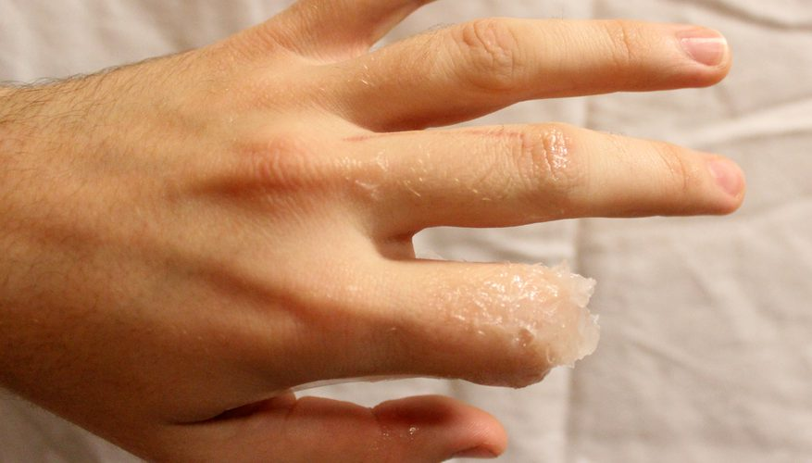
Roll a small piece of Vaseline or wax into a cylinder and shape the cylinder into a ring around the knuckle of the finger at the place where the rest of the finger is supposed to be chopped off. Blend the edges of the Vaseline or wax into you actual skin using a spatula and moisturizer. Add character to the "gash" by softly carving, jagged edges.
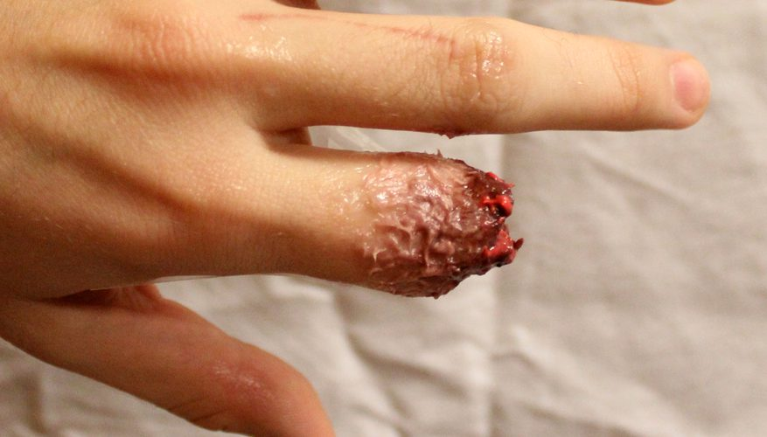
Paint the skin a brownish color with a liquid eyeliner brush and use cream makeup to add red and blue tones from the cut end of the finger to the end of the hand, gradually fading into the natural skin color.
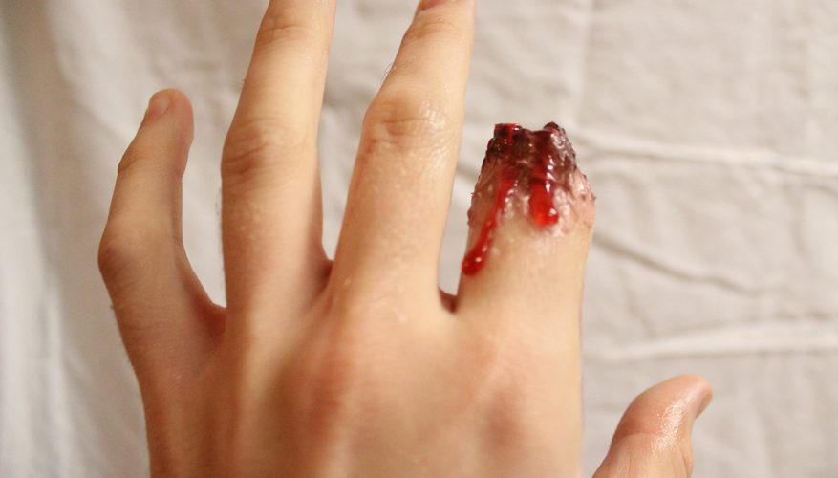
Soak a piece of tin fake blood to attach to the Vaseline to make it look like there are shreds of flesh on the end of the finger. Paint the surrounding area of the inside of the wound black and dark red. Pour some fake blood on to it to make it look like it’s still bleeding.

Tip
Apply cold cream before applying fake blood so it will stick properly.
Wash and dry your face before applying homemade cream makeup; wash off with soap and water.

Warning
Using food coloring for makeup may result in short-term skin staining, even after washing.

