Paper Mache Food

Learning Objectives
After studying this lesson your students will be able to:
- Demonstrate how to actually design some real stage props
- Explain how a dramatic production can benefit from stage props
- Explain why props are so important to a stage production

Challenge: Create a paper Mache food prop that could be used on stage. Directions for your creation are below!

MAKING MACHE
Let’s dive right into the fine art of making paper mache by first dividing it into two broad categories: The paper strip method and paper pulp method. Everything else is a variation of the two.

The paper strip method
It is safe to say that using paper strips is often better for children who are making mache. Using paper strips is pretty simple:
- Make your paste of choice (more on that in a minute).
- Cut or tear paper into strips.
- Soak them in your paste until they are saturated.
- Place the strips on your backing structure.
- Allow it to dry thoroughly.

Making standard paste
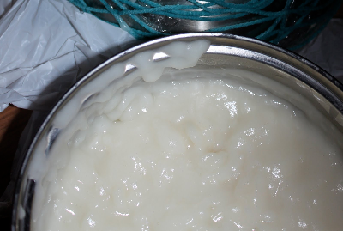
Of course, paper mache without the gooey paste that binds it together is not paper mache at all; That’s just called confetti or spit-wads. There are quite a few different methods for making this paste. Let’s look at a few different handy recipes.
- Use one part flour to five parts water. Boil this mixture for three minutes. This method is pretty inexpensive.
- For a no-boil paste, use one part flour and one part water stirred together until the consistency is smooth.
- Take it up a notch by using three parts white glue to one part water. This is a bit more expensive but pretty simple.
- Topping the list in the “Easy like Sunday morning” department: Run down to your local department store and buy a tub of liquid starch. It doesn’t get much easier than that.

WHAT TO USE FOR BASE MATERIALS
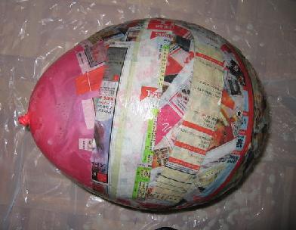
Since no awards are given for the heaviest craft creations, you will need to find a structure that is roughly the shape of your desired craft and add layers of paper mache on top of this base material. With a little creativity, nearly anything can be used as a base material:
- Balloons
- Plastic soda bottles (2 liter, 1 liter etc.)
- Crumpled aluminum foil
- Chicken wire
- Crumpled newspaper
- Small boxes
- A cheap, inflatable bouncy ball

Get creative with these base shapes before moving to the mache application phase. Plastic soda bottles can be cut and taped into a number of different shapes that will already resemble your craft. Crumple aluminum foil and apply it to the pop bottles to perfect the shape of your base. A little effort here will significantly reduce the amount of paper mache that you will need to use.

