Roman Theatre Quick Facts

The decline of Greek government and society coincided with the rise of the Roman Republic and subsequent empire. The Romans borrowed extensively from Greek theatre. Although Roman theatre may not be held in the same high esteem as that of the Greeks, we have inherited much from the influence of the Roman Theatre, including the word "play" itself, which derives from a literal translation of the Latin word ludus, which means recreation or play. Roman theatre took two forms: Fabula Palliata and Fabula Togata. Fabula Palliata were primarily translations of Greek plays into Latin, although the term is also applied to the original works of Roman playwrights based upon Greek plays. We are familiar with the latter from the works of Terence (190-159 B.C.), who introduced the concept of a subplot, enabling us to contrast the reactions of different sets of characters to the same events or circumstances. The Fabula Togata were of native origin, and were based on more broadly farcical situations and humor of a physical nature. An author of some of the better examples of this type of drama is Plautus (c.250-184 B.C.).
Again, perhaps as a reflection of the society itself, performed drama in Rome consisted primarily of Fabula Togata, as well as the spectacles of the gladiators and chariot races made familiar by modern Hollywood treatment of the Roman Empire. Plays of a more serious literary nature continued to be written, but these were not intended to be performed so much as read or recited. Although we have few works by Roman playwrights surviving to us in forms that would lend themselves to revival, the influence of the Roman world on the form of the stage is one which had more lasting effect. The semi-circular orchestra of the Greek theatre came to be eclipsed by the raised stage and the more vigorous style style of acting employed by the performers. However, the greatest impact Rome may have had on the theatre was to lower it in the esteem of the Church -- an impact that was to retard the growth of the dramatic arts for several centuries.

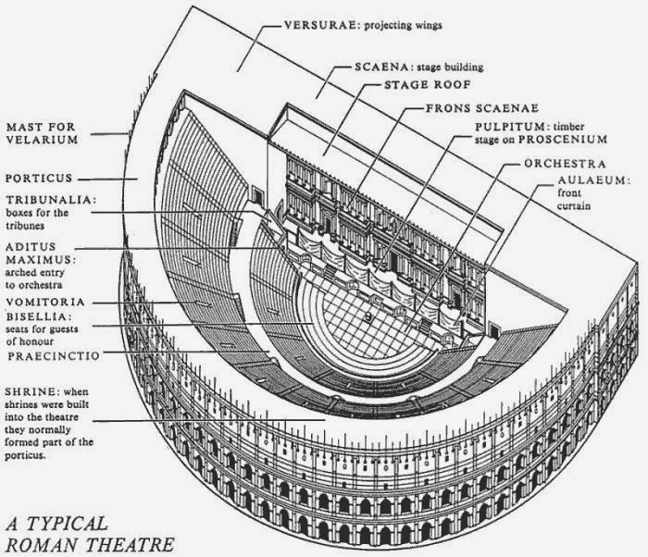

Aristotle’s 6 Elements of Theatre/Drama
- Plot- the ordering of the incidents in the play
Exposition – “the giving of information about past events” – beginning of the play
Point of attack – “where the playwright begins the plot”
Action – “the central chain of events in the play, particularly those events of a character’s attempt to achieve an important goal”
Action is made up of:
Discovery – when a character identifies an obstacle and decides what to do about it
Reversal – most plays make use of a reversal or a moment where the main characters plans do not meet their expected outcome. This usually stems from a discovery about a Character flaw
Major Dramatic Question – the overarching question posed by the play between the main characters
Complications (there will be more than one throughout the Action) – middle of the play
- “the imposing or entangling of the action” the cause of rising dramatic tension throughout the action, obstacles to the path of the main characters
- Complications can be caused by conflict – “clash of characters, seen as objectives that create obstacles for one another, or as actions, neither of which can succeed unless the other fails”.
The bent toward low comedy and its mass appeal -- coupled with its association with the entertainment of the arena (which involved the martyrdom of early Christians) -- almost certainly contributed to its disfavor by officials of the early Christian Church. Plays, or ludii were associated with either comedy of a coarse and scurrilous nature, or with pagan rituals and holidays. It was the latter, however, which may account for the survival of theatre through the Middle Ages.
Rising action – the escalation of complications
Crises – the turning point in the action where complications seem to be the most insurmountable. Usually involves a major reversal
Resolution or dénouement – “the declining action as crisis is passed and complication is resolved

Kinds of plot
Linear plot – a series of causes and effects that build on one another until a climax is reached. Usually these plays only move one direction in time, forward.
Episodic plot – the complications of the plot do not build on one another as with a linear plot; rather they are broken into segments of theme or idea that where that theme or idea is flushed out from beginning to end before moving on. These kinds of plots can skip around a time line.

- Character- the tools of the play – they are representations of the themes of the plot, boiled down to their essence to exemplify to an audience a multitude and often opposing points of view about the major dramatic question of the plot.

Kinds of characters
Protagonist - the central character of the play around whom the major dramatic question revolves
Confidant - a character who the protagonist confides in
Antagonist - the character who stands in the protagonist’s way

How we get to know the characters
Actions – what the character does to “affect the course of the story”
Dialogue – the text of the play that is spoken by the characters
Subtext – a deeper meaning to the actual dialogue spoken, the reason a character says what he or she says within the context for the plot, theme, and dramatic question
Stage directions – an author may make note of how a character is dressed, holds him or herself, or a characters reactions that have no dialogue such as laughing, crying, or dyeing.
Parentheticals – emotional descriptions of how dialogue is to be delivered usually in parenthesis and italicized

- Idea – What does the play mean as a whole? Does it have more than one idea it is trying to communicate? What are the themes? Why write, read or perform this play?
Where to find the idea
Drama – the form of theatre that tells a story about people, their actions, and the complications that result.
Conflict – “key to the movement of the story and is what qualifies a work as a play”

- Language – “the dialogue used to create the thought, character, and plot”
Parts of language that are important to the play
Word choice in dialogue to create a sense of character
Word choice in dialogue to create conflict and complications
Dialect
Metaphors or symbolism

- Music or Song – while not specifically referring to actual singing or musical instruments used during a production, this portion of a play also refers to the way that the dialogue sounds when spoken aloud.
Things to listen in dialogue
Rhythm – “regular and measurable repetition”
Tempo – how quickly dialogue is spoken
Accent – how loud dialogues is given and weather it is given in
Staccato short small pointed sections often very quick ideas
Sustained long drawn out sections often involved ideas
- Spectacle – the visual elements of a play (according to Aristotle but has grown to include many other elements in modern production techniques including sound and smell)
Where to find keys to envisioning the spectacle of a play
stage directions
descriptive dialogue
subtext

Deus Ex Machina
This Latin phrase originally described an ancient plot device used in Greek and Roman theatre. Many tragedy writers used Deus ex Machina to resolve complicated or even seemingly hopeless situations in the plots of their plays. The phrase is loosely translated as “god from the machine.” This translation refers to how the Deus ex Machina was often performed in ancient theatre. An actor playing a god or goddess would be lowered on stage by a “mechane” which was the name of the crane device used.
