Audition/ Monologue Requirements
“Shoot for the moon. Even if you miss you’ll land among the stars.”

Standard(s)
TAHSADIII.3 Acting by developing, communicating, and sustaining roles within a variety of situations and environments.
Learning Targets/Goals
- Understand the demands of the college audition process.
- Prepare 2 monologues that can be used for audition and scholarship purposes.
There are 2 assessment grades included in this assignment. You will be assessed on:
- 2 Monologue Performances
- A Mock Audition

Assignments:
Choose one of the top theatre schools listed below (or another school you are interested in attending as a Theatre major). You will prepare and perform two contrasting monologues in a simulated audition for that school. The monologue you select should come from a play or musical that you can obtain the entire script to. You will be required to read the entire script. You will be scored and graded by a panel of industry professionals and or recent graduates. Please take this opportunity seriously.
The monologue rubric for this assignment can be found on the weebly page.
The Audition grade will come from the following:
- Actor Resume
- Headshot
- Slate
- Dance Call
- Personality/Presentation in Audition

The University of Michigan’s Monologue Requirements
Prepare two short, contrasting monologues from plays. The monologues must be memorized and should be performed in the context of the entire play. The monologues should be no longer than 90 seconds each. Each monologue must be memorized and should be performed in the context of the entire play. The emphasis is on simple reality.
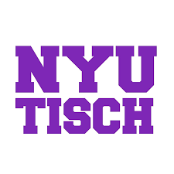

NYU Monologue Requirements
Two contrasting monologues — both contemporary
- We define “contemporary” as anything written from around 1900 to now
- Each monologue must be under 2 minutes in length
- All monologues must be from published plays (no film/TV scripts; no original material)
- Please choose material that is within your age range (roles you would be cast in now)
- Props and costumes are not permitted
- We want to hear your natural voice. Please do not add an accent to your monologues

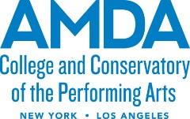
AMDA

Undergraduate degree in acting for stage, film and television
Two two-minute contrasting monologues (contemporary or classical). The audition performance should not exceed four minutes in total. Monologues should be from published plays. Original materials should not be used. The use of props during your audition is not permitted.

