Headshot Notes

COMMERCIAL HEADSHOTS
Commercial headshots are designed to appeal to the advertising industry. The purpose of a commercial is to promote a product to a specific demographic. In your commercial headshot, you really want to consider what demographic you fall into. It’s important for the personality types in commercials to be easily identifiable since there are only a few seconds to connect with the viewer. Are you the upscale luxury car driver or the college student compact car driver? What is your authentic age range? Are you the stylish hipster phone commercial type or the nerdy, quirky office type? As always, you want to show unique qualities in your headshot. But keep in mind, commercial headshots are really about that broader appeal.
- Wardrobe: Your commercial headshot should be warm and bright so you come across as likable. It’s best to wear a color that pops, like jewel tones that draw attention to a shot without overshadowing the actor. Blacks or grays tend to take away from the warmth and energy of a shot. If you only have dark clothing, make sure your background is brighter.

THEATRICAL HEADSHOTS (This is what you will be doing)
Theatrical headshots are geared towards being cast in plays, TV shows, and films. In theatrical headshots, you really want to see the layers of an actor’s personality. Generally speaking, theatrical headshots show a little more emotional depth than a commercial headshot. In commercial headshots, it is important to come across as trustworthy so you can sell a product. In theatrical headshots, you are selling an identifiable personality type, whether it’s a trustworthy one or not.
- Serious or smile? : Typically, theatrical headshots are thought of as confident expressions without a smile, but it really depends on the types of characters you’re going out for. Sometimes a knowing smirk or vulnerability behind the eyes better exemplifies who you are as an actor. Not all theatrical shots need to be stoic and serious. I like to think of the theatrical headshot as feeling more grounded.
- Wardrobe: The types of characters you go out for will determine wardrobe in theatrical headshots, but I tend to like earthy tones. While I try and stay away from black or white shirts, I do find some grays acceptable in theatrical headshots. Just make sure that there is an adequate contrast ratio between wardrobe, background, and hair. You don’t want your headshot to be muddy or dull just because it’s theatrical. I find that earth tones can be rich in color to stand out, but still subtle enough to give focus to the actor.
Assignment
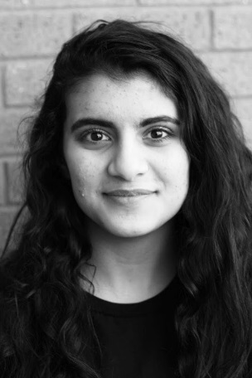
You are obviously shooting these on your phone and printing from a standard printer (this will be taken into consideration). Try shooting on a phone with portrait mode or a DSLR. Below are examples of good quality theatric headshots:

