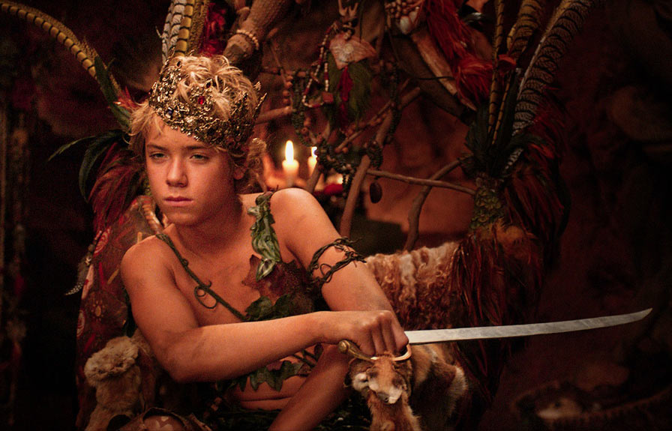

**Name: Peter Pan**

**Age: very young**

**Height: 5ft**

**Eye Color: green**

**Hometown:**  **born in London, claims Neverland**

**School: elementary drop out**

**Work:**  **PLAY: fighting pirates, leading Lost Boys**

**facebook**

**f**

**Talents: Sword fighting, swimming, leadership, impersonations, flying**

**Three Characteristics: (example: bad temper, selfish, brainiac) forgetful, immature, loyal**

**4 friends on Facebook: Wendy, Tinker Bell, Tiger Lily, the lost boys**

**Most important event in your life: when I ran away from home and found Tinker Bell**

**Best memory**: **getting a kiss from Wendy**

**If your life had a theme song: I Believe I Can Fly**

**Other notes: I’m secretly afraid of losing Wendy**

**What is your objective? (What do you want from your scene partner?):**

**List 3 tactics you will use:**