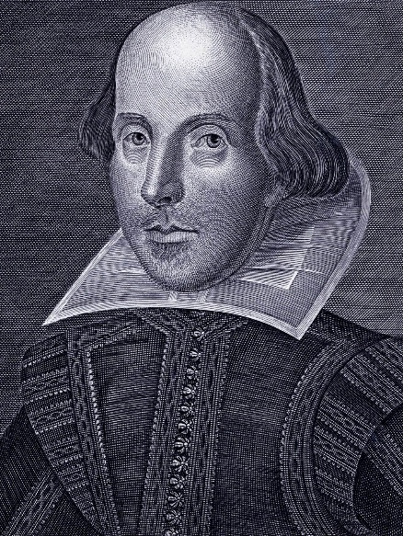
Shakespeare Notes

Birth and Childhood
William Shakespeare was probably born on about April 23, 1564, the date that is traditionally given for his birth. He was John and Mary Shakespeare's oldest surviving child; their first two children, both girls, did not live beyond infancy.
Their father, John Shakespeare, was a leatherworker who specialized in the soft white leather used for gloves and similar items. A prosperous businessman, he married Mary Arden, of the prominent Arden family. John rose through local offices in Stratford, becoming an alderman and eventually, when William was five, the town bailiff—much like a mayor. Not long after that, however, John Shakespeare stepped back from public life; we don't know why.
Shakespeare, as the son of a leading Stratford citizen, almost certainly attended Stratford's grammar school. Like all such schools, its curriculum consisted of an intense emphasis on the Latin classics, including memorization, writing, and acting classic Latin plays. Shakespeare most likely attended until about age 15.
Marriage and Children
A few years after he left school, in late 1582, William Shakespeare married Anne Hathaway. She was already expecting their first-born child, Susanna, which was a fairly common situation at the time. When they married, Anne was 26 and William was 18.
In early 1585, the couple had twins, Judith and Hamnet, completing the family. In the years ahead, Anne and the children lived in Stratford while Shakespeare worked in London, although we don't know when he moved there. Some later observers have suggested that this separation, and the couple's relatively few children, were signs of a strained marriage, but we do not know that, either. Someone pursuing a theater career had no choice but to work in London, and many branches of the Shakespeares had small families.
London Theatre
For several years after Judith and Hamnet's arrival in 1585, nothing is known for certain of Shakespeare's activities: how he earned a living, when he moved from Stratford, or how he got his start in the theater.
Following this gap in the record, the first definite mention of Shakespeare is in 1592 as an established London actor and playwright, mocked by a contemporary as a "Shake-scene." For more than two decades, Shakespeare had multiple roles in the London theater as an actor, playwright, and, in time, a business partner in a major acting company, the Lord Chamberlain's Men (renamed the King's Men in 1603). Over the years, he became steadily more famous in the London theater world; his name, which was not even listed on the first quartos of his plays, became a regular feature—clearly a selling point—on later title pages.
Final Years
Shakespeare prospered financially from his partnership in the Lord Chamberlain's Men (later the King's Men), as well as from his writing and acting. He invested much of his wealth in real-estate purchases in Stratford and bought the second-largest house in town, New Place, in 1597.
Among the last plays that Shakespeare worked on was The Two Noble Kinsmen, which he wrote with a frequent collaborator, John Fletcher, most likely in 1613. He died on April 23, 1616—the traditional date of his birthday, though his precise birthdate is unknown. We also do not know the cause of his death. His brother-in-law had died a week earlier, which could imply infectious disease, but Shakespeare's health may have had a longer decline.
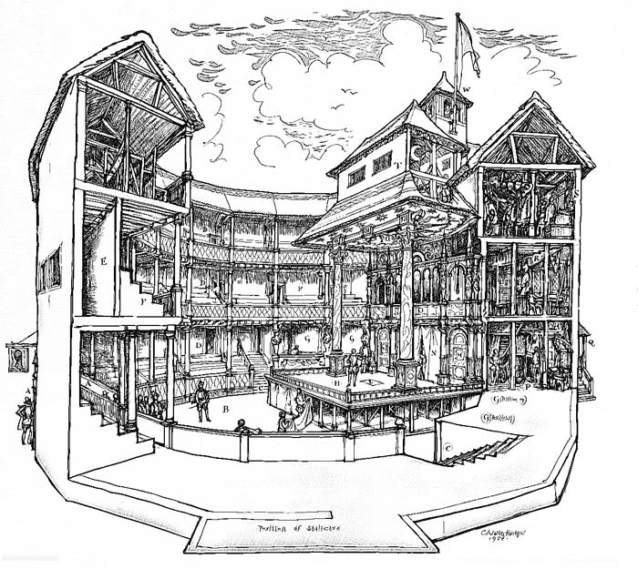
Shakespeare’s plays are usually separated into three main divisions
Comedies – ‘All’s well that Ends Well’, ‘Much Ado About Nothing’
Histories – ‘Henry V’
Tragedies – ‘Romeo and Juliet’, ‘Hamlet’, and ‘Othello’.
The Globe Theatre: The Globe Theatre was a theatre in London associated with William Shakespeare. It was built in 1599 by Shakespeare's playing company, the Lord Chamberlain's Men, on land owned by Thomas Brend and inherited by his son, Nicholas Brend and grandson Sir Matthew Brend, and was destroyed by fire on 29 June 1613.

Fun Facts!
- “Wherefore” actually means “why.” When Juliet’s lamenting “Wherefore art thou Romeo?” she’s not asking where he is, literally. In modern English, she’s asking, “Why do you have to be a Montague? Just last night my parents were talking about how snobby and boring your parents are! Why couldn’t you be a Johnson, or a Smith? Way to ruin my night, pretty boy.”
- If you think it’s a sex joke, it’s a sex joke.
- "The Lion King” is based on “Hamlet” … only with less drowning and insanity.
- Shakespeare’s plays were originally performed by all-male casts.
- "Titus Andronicus" is Shakespeare’s most graphic and gruesome play. While it’s brilliantly written, if you have a weak stomach (or had meat pie for dinner), avoid this one.
- Because he and his plays are dead and/or really old, Shakespeare’s works are all public domain. That’s why you see them performed so often; they’re free!
- Along with innuendos, cross-dressing is rampant in Shakespeare’s plays. If you don’t think it’s funny, it’s probably just because you weren’t born in the 15th century.
- Shakespeare invented over 1,700 words in the English language, most importantly bedazzled (“Taming of the Shrew”) and swagger (“Henry V” and “A Midsummer Night’s Dream”). He also invented the “yo mama” joke.
- It’s believed that “Macbeth” was embedded with actual curses and spells by Shakespeare himself. As such, if you say “Macbeth” inside a theater (while not performing in the play), don’t be surprised if your actor friends usher you outside to enact the counter-curse. While I’m sure it varies around the world, this is the counter-curse I’m most aware of: go outside, spin around three times (counter-clockwise), say a curse word, and spit.
In his will, he appeared to only give his wife (Anne) a bed.
Shakespeare’s grave includes a curse against moving his bones.

